Project Proposal: Fraud Detection in Digital Music Supply Chains

1. Gap Analysis: Missing Signals in Current Schema
I reviewed the origin_tag_spec schema you provided and found three main gaps in the data. The current setup is good at checking identity details like account age and email, but it misses "Action Telemetry." This means we are not tracking what the user is doing while they are uploading files. I recommend adding these three tags to the MVP to fix these holes.

Gap 1: Upload Session Velocity (The "Superhuman Speed" Gap)
Missing Metric prov_upload_interaction_duration_secs
Rationale The current rules track how many songs are uploaded (beh_uploads_last_24h) but not how fast the upload happens. This is a big problem because a script can upload files much faster than a human can. The Bureau ID report on bot detection states that human mouse movement typically has hesitations, changing speeds, and indirect paths. In comparison, bots move in straight lines and are very efficient [3].
Deduction Since legitimate human users naturally have these delays and hesitations, I plan to model real upload times using a Log-Normal distribution. This will allow me to mathematically separate real users from the instant, linear speed of bot scripts.
Fraud Vector "High-Velocity Injection." A bot can upload 50 songs in just a few seconds. If they spread these uploads across different accounts, they can avoid the volume limits. If we don't have a timestamp that measures exactly how long the upload took from start to finish, we can't see this happening.

Gap 2: IP Context at Upload (The "Bait & Switch" Gap)
Missing Metric prov_upload_ip_datacenter_flag
Rationale Right now, the system only checks the IP address when the user signs up. However, PacketStream's analysis mentions "Hybrid approaches" where users combine different proxy types. They often use Residential IPs for access and Datacenter IPs for speed [4]. They also note that Datacenter proxies are often 5 to 10 times faster than residential ones [4].
Deduction Because Datacenter IPs are so much faster, I believe smart fraudsters will use a "Bait and Switch" strategy. They will use a clean Residential IP to pass the signup check, and then switch to a faster Datacenter IP when they need to upload a lot of files.
Fraud Vector "Location Spoofing." If we don't check the IP type again during the upload, the system is vulnerable to this specific switching attack.

Gap 3: Audio Dynamic Range (The "Silent Stream" Gap)
Missing Metric prov_audio_dynamic_range_score
Rationale The current schema uses prov_audio_hash to find duplicates of known songs. But HUMAN Security reports that a common fraud trick is using "Generative AI" to make thousands of files that are technically unique but are just noise or silence [1]. These are used to farm royalties.
Deduction Since these "Ghost Tracks" are unique files, the current hash check won't catch them. Therefore, I propose using a dynamic range score. This will flag files that don't have any musical changes, like pure silence or constant static, and catch this kind of AI spam.

2. Proposed Detection Hypotheses
Based on the tags I saw in the origin_tag_spec file, I designed these three models to flag fraud.

Hypothesis 1: The "Bot Volume" Threshold
Logic A Quartz investigation into streaming fraud notes that for a click farm to make money, a single account has to stream continuously and generate thousands of plays a day [2].
Deduction Real artists usually upload sporadically, which follows a Poisson distribution of rare events. Bot farms need consistent, high volumes to be profitable. Because of this difference, I can set a strict statistical limit to separate them.
Target Tag beh_uploads_last_24h
Threshold More than 15 uploads per day.

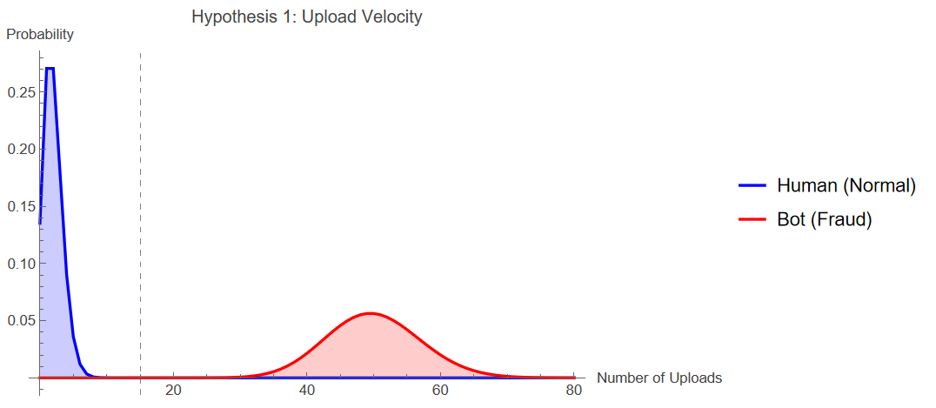
Hypothesis 2: Geolocation Spoofing
Logic PacketStream points out that Residential IPs are hard to detect but slow, while Datacenter IPs are easier to flag but much faster for automation [4].
Deduction I assume that 99% of legitimate users will have a Residential IP that matches the country they are in. On the other hand, a "Location Mismatch"—like saying you are in the UK but uploading from a Cloud Server in Russia—is a very strong sign that someone is using a proxy to hide their identity.
Target Tag id_country_ip_mismatch_flag
Threshold TRUE (Flagged).

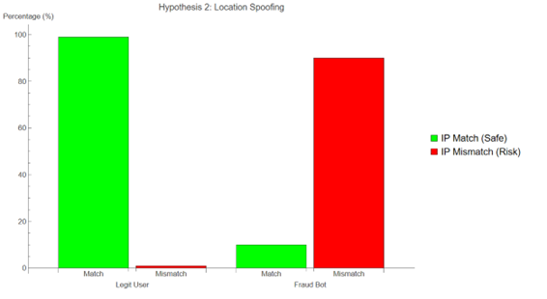
Hypothesis 3: Metadata Keyword Spam
Logic The HUMAN Security report mentions that fraudsters use "Generative AI" to mass-produce metadata targeting specific search terms [1].
Deduction This automated process creates a statistical anomaly. Real song titles follow a normal language distribution. Spam titles cluster around specific keywords. This creates a clear outlier in the "Spam Score."
Target Tag prov_metadata_keyword_spam_score
Threshold Score higher than 60.
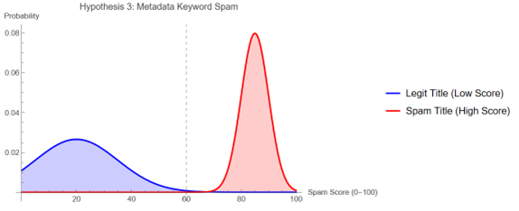

3. Proposed Methodology: Hybrid Detection Framework
To test the hypotheses above, I propose a two-stage detection system that fits into the Zync API.
Stage 1: Statistical Thresholding (The Baseline)
- Objective: Set a clear baseline for "obvious" fraud using the Priority 1 tags you already have.
- Technique: I will use the Poisson and Normal Distribution models I showed earlier. By calculating the Cumulative Distribution Function (CDF) for tags like beh_uploads_last_24h and prov_metadata_keyword_spam_score, I can mathematically figure out the probability of a user's behavior happening by chance.
- Application: Any user that falls into the extreme tail (p < 0.01) of this distribution will automatically get flagged for the "Evidence Pack."
Stage 2: Unsupervised Anomaly Detection (The Innovation)
- Objective: Catch the "Low-and-Slow" bots that try to stay just under the Stage 1 limits (like uploading 14 songs to avoid the 15-song limit).
- Technique: I will use Isolation Forests (iForest). Research from Virginia Tech on music datasets shows that unsupervised learning is good at finding "corrupted or distorted" entries even if you don't have labeled training data [5].
- Justification: This method is important for finding fraud patterns we don't know about yet, like the "Ghost Tracks" I mentioned in the Gap Analysis, without needing to train the model on them first.

4. References
- HUMAN Security (2025). AI-Powered Streaming Fraud: How to Make a Hit Song Nobody Listens To. Available at: https://www.humansecurity.com/learn/blog/ai-powered-streaming-fraud/
- Quartz (2016). Music streaming has a nearly undetectable fraud problem. Available at: https://qz.com/615359/steady-chunks-of-money-are-being-quietly-illicitly-stolen-from-music-streaming
- Bureau ID (2025). Mouse Movement Behavioral Patterns Can Reliably Tell Bots from Humans. Available at: https://bureau.id/resources/blog/mouse-movement-behavioral-patterns-can-reliably-tell-bots-from-humans
- PacketStream (2025). Residential Proxies vs. Data Center Proxies. Available at: https://packetstream.io/residential-proxies-vs-data-center-proxies/
- Virginia Tech (2016). An Unsupervised Approach to Anomaly Detection in Music Datasets. Available at: https://vtechworks.lib.vt.edu/

